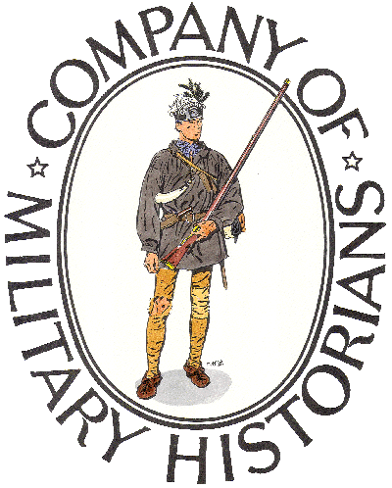
JEFFERSON BARRACKS CHAPTER
COMPANY OF MILITARY HISTORIANS

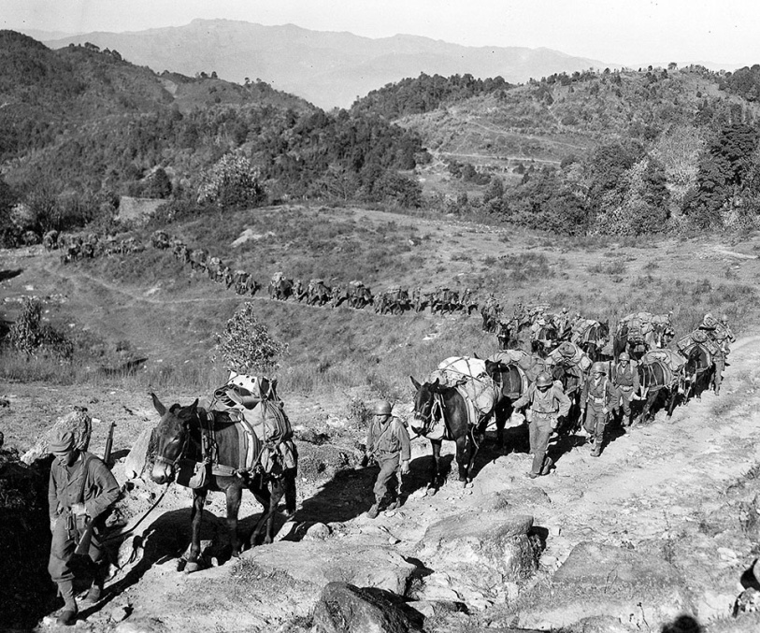

NEXT MEETING
MONDAY, MARCH 7, 2022, AT 7 P.M.
IN THE PAVILION AT LEMAY AT
JEFFERSON BARRACKS COUNTY PARK
305 GREGG RD.
SOUTH ST. LOUIS COUNTY, MISSOURI

PRESENTATION:
THEY CALLED THEMSELVES “MARSMEN”
THE MARS TASK FORCE IN BURMA 1944-45
PRESENTED BY
RANDY BAEHR

THE PROGRAM IS FREE TO THE PUBLIC.

Randy Baehr, Jefferson Barracks Chapter member, will talk about the little-known World War II campaign of the 5332nd Brigade (Provisional), called the MARS Task Force, to open a land route through Burma between India and China, including the stories of his own father’s brief experiences as a replacement soldier with the MARSmen.

The Company of Military Historians is a national educational, scientific, and literary institution devoted to the study and dissemination of “information on the material culture, history, and traditions of members of the Armed Forces of the United States worldwide and other nations serving the Western Hemisphere”.

