The 74th CMH “Fredericksburg” Meeting in 2023 will be on 27--29 April
Location will be the Hampton Inn Stafford Quantico/Aquia, right off I-95 at
2925 Jefferson Davis Highway, Stafford, VA 22554 • Reservations 540-657-0999
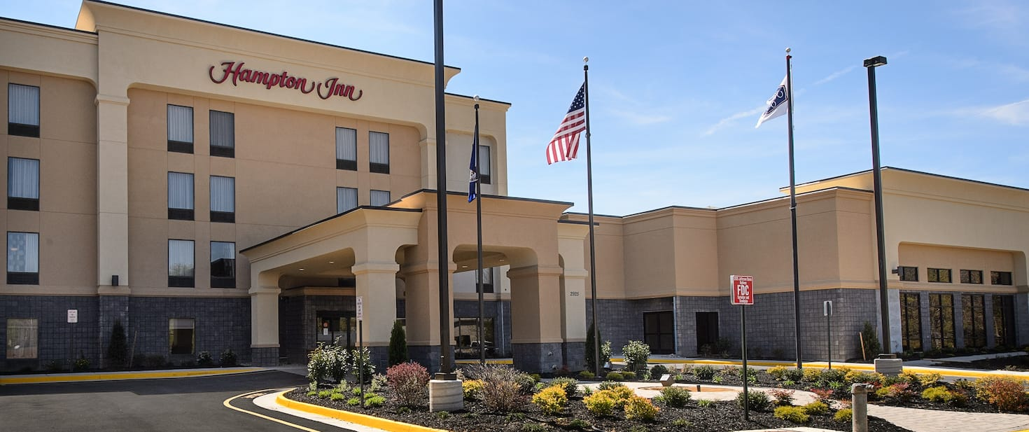
Meeting Plan
- The meeting will begin on Friday with a Power Point overview of the Fredericksburg and Chancellorsville battles. After the Fredericksburg battle tour we will be hosted for lunch at the A. Smith Bowman Distillery of Fredericksburg, which is the oldest distillery in Virginia. A. Smith Bowman Distillery | Tour Virginia's Oldest Distillery (asmithbowman.com) . A tour of the distillery along with bourbon sampling is also optional. We will then board busses for the Chancellorsville battlefield, with NPS historians assisting interpretation.
- The meeting is being held one week before the 150th anniversary of the Battle of Chancellorsville, 4-6 May 1863, and the death of GEN Thomas J. ‘Stonewall’ Jackson.
- Saturday will include 6 audio-visual presentations at the hotel’s conference center.
- We will have exhibit and sales tables, but reserve early as there is limited space.

One Registration Fee for Everything
- The registration fee will include breakfast (for hotel guests), lunch and dinner on both Friday and Saturday. Yes, it includes the Saturday evening CMH Banquet as well, plus coffee during breaks in the presentations. and Free Wi-Fi at the hotel
- Also included is an open beer and wine bar for both the Thursday evening reception for early arrivals, and the Saturday evening reception before the Banquet.
- CMH room rate is $99.00, available both before and after the meeting dates.
- Comfort and convenience between Fredericksburg and Quantico, with plenty of historical sites. This is the 250th Anniversary of the establishment of the USMC, and the National Museum of the Marine Corps is only a 20 minute drive north of the hotel. Shops and dining abound at the Stafford Marketplace and North Stafford Plaza, only a mile from the hotel. Old town Historic Fredericksburg is 20 minutes away.
- The hotel phone number is 540-657-0999 ask for the ‘CMH’ $99.00 room rate. We have a block of rooms but they might run out early so book ASAP.
We look forward to seeing you this Spring for a great meeting!

