*Chesapeake Chapter Members:*

Our next Chapter meeting will be at 10:00am on **Saturday December 14th, 2024** at the NRA headquarters auditorium.  Please mark your calendar.

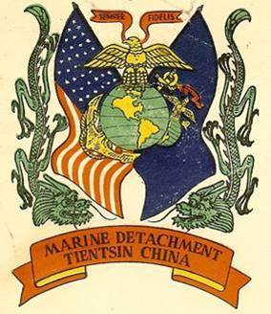

***The Glory Years of the China Marines 1920-1940***

A general history….this presentation during those years of the China Marines as told through photos and artifacts by ***Chapter member Dirk Salverian.***

<http://chinamarine.org/Shanghai.aspx>  will give you a good background… this link gives an excellent history of the China Marines.

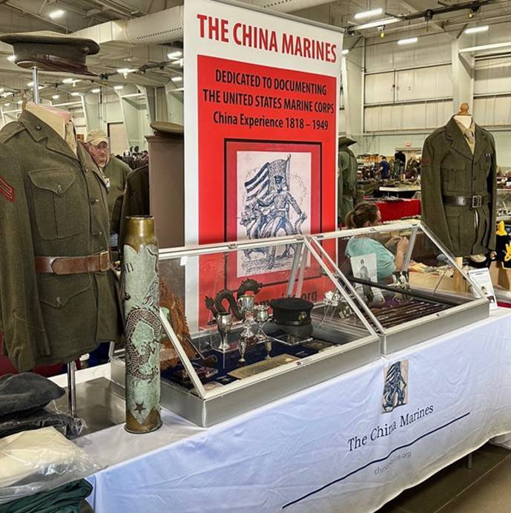        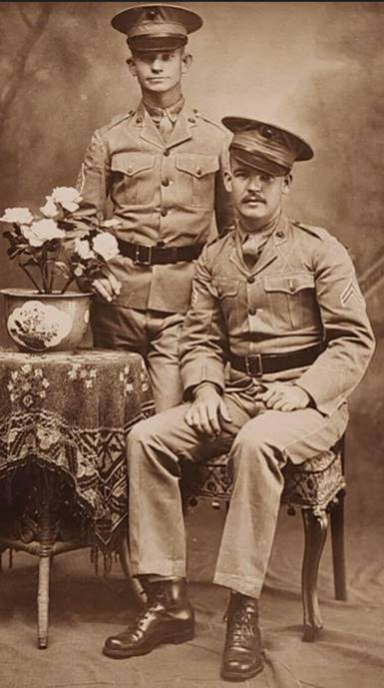

***Dirk’s China Marines display at a CMH National meeting***

Dirk Salverian, joined the Company several years ago, under the sponsorship of Ken Smith-Christmas. A retired Air Force Officer, Dirk now serves as a senior civil servant within the Department of Defense. He specializes in collecting all things related to the China Marines. This title refers to *Marines that served in or along the coast of China between 1818 and 1949*.  Be sure to join us for a very interesting presentation on a topic that’s not often discussed. Be sure to bring items from your collection that supports the topic.

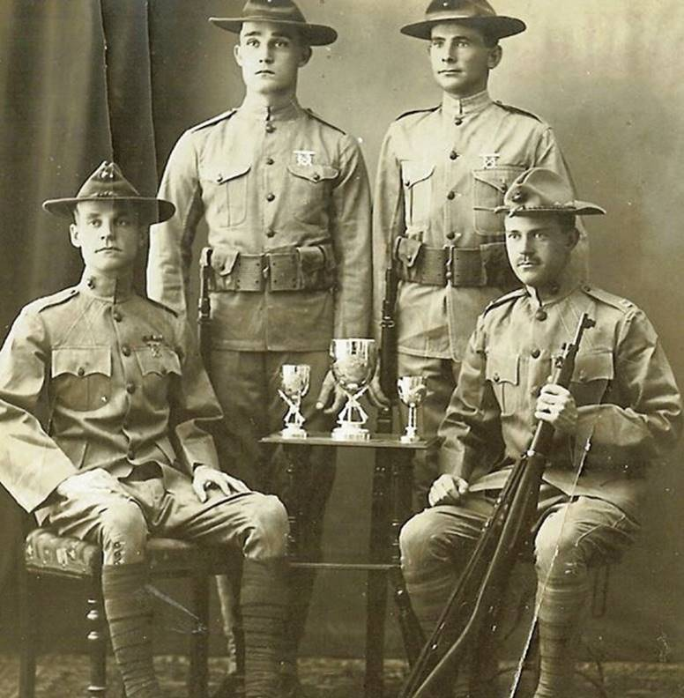

***Early China Marines… circa 1910***

<https://www.nramuseum.org/museums/national-firearms-museum.aspx>

*11250 Waples Mill Rd, Fairfax, VA 22030*

*NRA National Firearms Museum, Address*

[Use Waze to drive to **NRA National Firearms Museum, 11250 Waples Mill Rd, Fair Oaks**: https://waze.com/ul/hdqcj04vbg](%20 Use%20Waze%20to%20drive%20to%20NRA%20National%20Firearms%20Museum,%2011250%20Waples%20Mill%20Rd,%20Fair%20Oaks: https:/waze.com/ul/hdqcj04vbg)

[https://maps.roadtrippers.com/us/fairfax-va/attractions/national-firearms-museum](https://nam02.safelinks.protection.outlook.com/?url=https%3A%2F%2Fmaps.roadtrippers.com%2Fus%2Ffairfax-va%2Fattractions%2Fnational-firearms-museum&data=04%7C01%7C%7C477986c2b6994d01761608d98f3fea43%7C0f593114db074e8baeb9baec19405505%7C0%7C1%7C637698326969222800%7CUnknown%7CTWFpbGZsb3d8eyJWIjoiMC4wLjAwMDAiLCJQIjoiV2luMzIiLCJBTiI6Ik1haWwiLCJXVCI6Mn0%3D%7C3000&sdata=Y3pC5OMhKHy4%2FZl10vbsWz6IsTDjnkkqmUyfL2%2BlNco%3D&reserved=0)

    Mark your calendar and make a point to join us!

The below link is information about **War gaming in Preps for WWII book talk**.  Alan thought this may be of interest for our members….enjoy.

<https://www.eventbrite.com/e/book-talk-with-dr-john-lillard-tickets-1074986546699?aff=ebemoffollowpublishemail&ref=eemail&utm_campaign=following_published_event&utm_content=follow_notification&utm_medium=email&utm_source=eventbrite>

Michael Osborne

Chesapeake Chapter CMH

[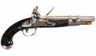](https://www.google.com/url?sa=i&rct=j&q=&esrc=s&source=images&cd=&cad=rja&uact=8&ved=&url=https%3A%2F%2Fwww.icollector.com%2FScarce-and-Desirable-U-S-Navy-Simeon-North-Model-1813-Flintlock-Pistol_i13750510&psig=AOvVaw0jrIFLSsTCfz7kBQuiuj6g&ust=1573581671730769)